History 277: Designing the American Dream
GEP: Historical Perspectives
Course Meetings: Tues, Thurs, Fri 10:00-10:50am CBB 135  Office Hours: 2-3pm Tues and Thursday 473 CCC | History Department  473 CCC  Dr. Neil Prendergast  nprender@uwsp.edu

What can American history teach us about design?

In this class, we will study three products of design at the heart of the American dream: the car, the mall, and the single-family house. As it turns out, their designs were each intended to address a social problem.

Automobile advocates argued that the car would end the social isolation of rural people. City planners claimed that home ownership, as opposed to apartment renting, would stabilize neighborhoods. Mall builders sensed a need for public space where communities could develop bonds of belonging. In each case, the product of design was inspired by some understanding of how the country was functioning—and how it ought to function better.

This semester, therefore, we will explore the connection between designers—engineers, architects, planners, graphic designers, and similar professionals—and the public conversation about our nation. A general answer to the question above, then, is that history can teach us that design finds much of its significance when it addresses social problems.

In addition to examining inspiration, we will also study success and failure. We know cars run, houses stand up, and many malls are still open, but how well did driving solve the problem of social isolation, or home ownership stabilize neighborhoods, or shopping build community?

As you will see, to understand design we must understand ongoing public discussions about large themes in American history, community foremost among them. In fact, community leads directly into democracy, race, gender, class, and the environment as areas of concern. This course, then, will be a solid introduction to our nation’s intellectual tradition, embedded as it is in those concerns. I believe the course will make you a more thoughtful designer with a greater, more significant impact on the people around you.

Enduring Understandings:

The designs behind the American dream reflect historical conversations about community.

Learning Outcomes: After taking this course, students will be able to:

- Describe and explain major changes in the history of the built environment
- Evaluate competing claims about the effects of design on community
- Question the landscape around them with thought and care

Course Structure: Each design—car, house, mall—has its own unit culminating in a written exam. A final paper on a fourth topic of the student’s choosing (with professor approval) will complete the semester.

The Schedule and Grading sections of the syllabus will answer most of your questions about course structure, but allow me a few words here to describe the basic mode of operations. Most weeks will require about 30 pages of reading. During class, I will lead a discussion of the reading to make certain we have an accurate understanding of it in common. Each discussion will then turn to students’ views on the reading, especially how students see the reading as helping us understand the unit’s guiding question. To keep discussion fresh, we will also examine historical sources, study visual evidence, and complete a variety of small challenges cooked up by yours truly.

Office Hours: You are welcome to visit me in my office. I set aside office hours so that I have the chance to talk with students one-on-one. My only commitment is to speak with my students.

To visit me during office hours you do not need an appointment. We can chat about anything going on in the course, from content to class dynamics. They are an especially good time to check in if you missed class. If you have class or work during my office hours, I am happy to make an appointment. Just email me.

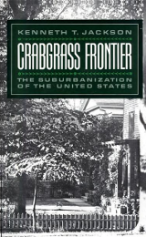 | 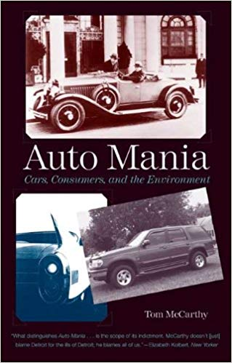 | 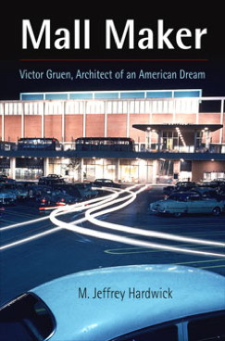

Purchas Books:
Kenneth Jackson, Crabgrass Frontier: The Suburbanization of the United States (New York: Oxford University Press, 1985).

Tom McCarthy, Auto Mania: Cars, Consumers, and the Environment (New Haven: Yale University Press, 2009).

Text Rental:
M. Jeffrey Hardwick, Mall Maker: Victor Gruen, Architect of an American Dream (Philadelphia: University of Pennsylvania Press, 2010).

Canvas: There will be some non-book readings available on Canvas.

Grading: three exams @ 25 points each + one final paper @ 25 points = 100 points.

Letter grades for the semester follow the typical pattern:

A 93-100 | B+ 87-89.99 | C+ 77-79.99 | D+ 67-69.99 | F 59.99 and below
A- 90-92.99 | B 83-86.99 | C 73-76.99 | D 60-66.99
 | B- 80-82.99 | C- 70-72.99
Advice from Previous Students in My Courses: Why listen just to me? Here is what your predecessors want to tell you:

“Read the material and attend class.”

“Attend class, pay attention and from there it’s not hard to do well in the class.”

“Stay caught up on the readings and highlight for the paper at the end.”

“Stay on top of the reading. It’s not too hard and the lectures cover the material, but the text gives a lot of depth and examples.”

“Involve yourself in the reading, thinking about how you could apply it to what you care about.”

“Be prepared to read! Pick up on little things.”

“Look beyond just the facts, because it is a very beneficial class.”

“Come to class and speak up. Participate. I found the class much more interesting when more people took part.”

Course Policies: During the class, cell phones and other electronic devices are prohibited. If you are a parent or are otherwise obligated to be available to your family via cell phone, then please discuss that situation with me, so I know that you have a good reason for keeping your phone turned on.  For information on plagiarism, consult http://www.uwsp.edu/centers/rights. See Chapter 14, Student Academic Standards and Disciplinary Procedures, pages 5 -10, for the disciplinary possibilities if you are caught cheating. As an instructor deeply concerned with fairness in the classroom, I pursue each and every case of plagiarism and cheating. Please note that turnitin.com is used for the essay assignments. | 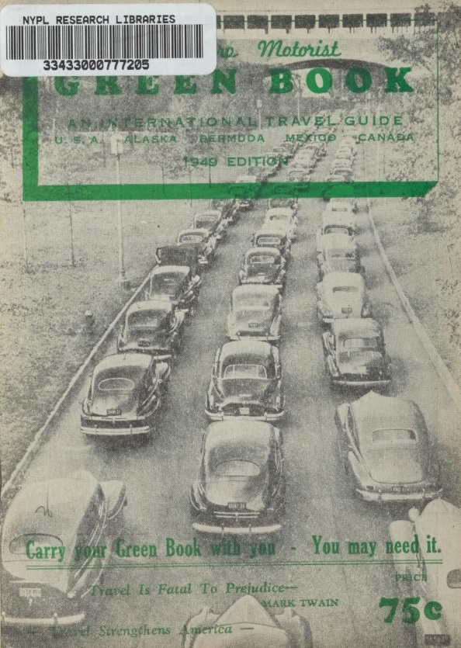
Life Happens: I understand you have a life outside this class. I understand that life might make it difficult to complete some assignments, attend class, or simply to do well. I do my best to be flexible because I know those circumstances are out of your control and my control. I’m on your team.

I also know that some real learning has to take place in this class. You will have more opportunity in life if you understand history, read critically, and write well. This class has to be one of your priorities. I do my best to be flexible, but I have to adhere to some standards. If something comes up, let’s talk.

Note: The syllabus is a general plan for the course. Changes announced in class, on Canvas, or via email may be necessary.

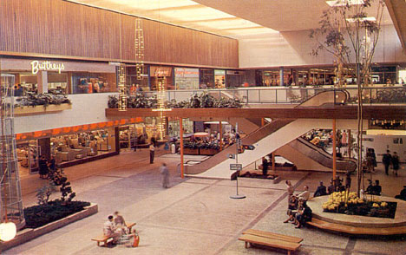 | Equity of Educational Access: If you have a learning or physical challenge which requires classroom accommodation, please contact the UWSP Disability Services office with your documentation as early as possible in the semester. They will then notify me, in a confidential memo, of the accommodations that will facilitate your success in the course. Disability Services Office, 103 Student Services Center, Voice: (715) 346-3365, TTY: (715) 346-3362, http://www.uwsp.edu/special/disability/studentinfo.htm.

(Schedule begins on next page)

Schedule:
Week 1 | Tuesday 1/21 | In Class Reading: | What is historical about design?
 | Thursday 1/23 | Canvas: “Civitas by Design” | How is design about community?
How did the single-family house become the norm in the United States—and to what consequences?

 | Friday 1/24 | Crabgrass Frontier, pp. 12-19 | What types of cities predated the suburban city?
Week 2 | Tuesday 1/27 | Crabgrass Frontier, pp45-54, 73-86. | What inspired the first positive vision of suburbs in the United States?
 | Thursday 1/29 | Crabgrass Frontier, pp. 87-92, 107-115 | How did railroads and streetcars shape suburbs?
 | Friday 1/31 | Crabgrass Frontier, pp., 124-137. | How did streetcar suburbs become more affordable?
Week 3 | Tuesday 2/3 | Crabgrass Frontier, pp. 138-140, 148-156. | How did city governments react to suburbanization?
 | Thursday 2/5 | Crabgrass Frontier, pp. 163-171, 181-189. | How did the car remake suburbs before World War II?
 | Friday 2/7 | Crabgrass Frontier, pp. 190-218 | What effect did the federal government have on the rise of suburban cities?
Week 4 | Tuesday 2/10 | Crabgrass Frontier, pp. 219-230 | What were the possibilities of public housing?
 | Thursday 2/12 | Crabgrass Frontier, pp. 246-271 | What were the basic qualities of postwar suburbs?
 | Friday 2/14 | No Class Meeting
Week 5 | Tuesday 2/18 | Canvas: “Selma of the North” | Why was a Fair Housing Act necessary?
 | Thursday 2/20 | Canvas: “Bulldozer in the Countryside” | What environmental problems did postwar suburbs pose?
 | Friday 2/21 | Crabgrass Frontier, pp. 272-282. | How well did postwar suburbs establish community?
Week 6 | Tuesday 2/25 | Exam Two
Why did the car become typical transportation in the United States?--and what effect did it have on the nation?

 | Thursday 2/27 | Auto Mania, 16-29. | What problems and possibilities did the early automobile present?
 | Friday 2/28 | Auto Mania, 30-45. | How did car ownership become widespread?
Week 7 | Tuesday 3/3 | Auto Mania, 55-76. | What impact did widespread car ownership have on natural resources?
 | Thursday 3/5 | Auto Mania, 77-84. | Why weren’t cars made to last longer?
 | Friday 3/6 | Auto Mania, 99-109, 115-129. | How did car ownership make someone part of a community?
Week 8 | Tuesday 3/10 | Auto Mania, 134-147. | What problems did American carmakers faces in the postwar era?
 | Thursday 3/12 | Auto Mania, 149-175. | What environmental problems did a car for every household create in the 1950s and 1960s?
 | Friday 3/13 | Auto Mania, 176-192. | How did the car industry respond to the environmental problems of widespread car ownership?
Spring Break
Week 9 | Tuesday 3/24 | Auto Mania, 193-206. | How did the federal government address the environmental problems of widespread car ownership?
 | Thursday 3/26 | Auto Mania, 207-230. | How did gas shortages transform the automobile?
 | Friday 3/27 | Auto Mania, 231-252. | What explains the rise of the SUV, given its well known environmental problems?
Week 10 | Tuesday 3/31 | Canvas: “Republic of Drivers” | What limited car ownership for ethnic minorities?
 | Thursday 4/2 | Canvas: “Gender and the Automobile” | What were the possibilities and limitations of automobility for women?
 | Friday 4/3 | Canvas: “Public Transportation” | How did car ownership supersede public transportation?
Week 11 | Tuesday 4/7 | Exam Two
How did malls become the foundation for 20th century consumer culture?

 | Thursday 4/9 | Canvas: “The Department Store” | How did people shop before malls?
 | Friday 4/10 | Mall Maker, pp. 48-71. | How did chain stores become widespread?
Week 12 | Tuesday 4/14 | Mall Maker, pp. 72-90. | How did wartime planning lead to the mall?
 | Thursday 4/16 | Mall Maker, pp. 91-117. | What ideas did retailers have for adapting to the car oriented landscape?
 | Friday 4/17 | Mall Maker, pp. 118-141. | How were the first shopping centers an attempt to remake public life?
Week 13 | Tuesday 4/21 | Mall Maker, pp. 142-161. | What problems did the first indoor malls attempt to solve?
 | Thursday 4/23 | Mall Maker, pp. 193-209. | What did postwar planners do to save downtowns?
 | 4/24 | Canvas: “Highways” | How did highways transform American cities?
Week 14 | Tuesday 4/28 | Canvas: “Retail and Inequality” | What effect did malls have on retail for ethnic communities?
 | Thursday 4/30 | Canvas: “Gender and Consumption” | What limits and possibilities did malls have for postwar women?
 | Friday 5/1 | Canvas: “A Consumer’s Republic” | What effect did malls have on community?
Week 15 | Tuesday 5/5 | Exam Three
 | Thursday 5/7 | Paper Workshop
 | Friday 5/8 | Paper Workshop

Final Paper Due 4:45pm Thursday, May 14th in Canvas. No paper copy necessary.

In inclement weather, we may hold class online. Check Canvas and your campus email when bad weather is forecasted.

